HPE 300 Unit Plan
Unit: Soccer

Part 1: Planned out calendar
Day 1. Soccer rules and overview
Day 2. Dribbling
Day 3. Passing and shooting
Day 4. Defense and small sided games
Day 5. Soccer Tournament

Part 2: Objectives
Unit Objectives:
Cognitive- students will be able to display their knowledge of soccer by taking a test.
Psychomotor- Students will be able to how to dribble, pass, shoot and defend through daily activities
Affective- Students will be able to display
Students will learn the rules and how to play the game of soccer the correct way.

Daily Objectives:
Day 1. Students will learn the rules and the in and outs of the game.
Day 2. Students will learn how to effectively dribble a soccer ball with their dominate and non-dominate foot.
Day 3. Student will learn the correct way of passing and shooting the ball.
Day 4. Student will learn the correct way of how to properly defend without fouling.
Day 5. Students will be able to demonstrate their skills and knowledge to test in a tournament.

Part 3: Lesson Plans
SEE ATTACHED.

Part 4: Materials related to Unit
Soccer balls, Soccer goals, Cones, tournament bracket

Part 5: Handouts
http://www.hanoverhornets.org/pe/wp-content/uploads/2017/02/soccer-study-guide-6.pdf

Part 6: Written Test
- There are 13 players on the field for an side at a time ? T/F
- Can any other player use their hands in soccer besides the goal keeper ? T/F
- Is there out of bounds in soccer ? T/F
- Are there penalty kicks in soccer ? T/F
- Are there timeouts in soccer ? T/F
- Are there 2 halves in soccer ? T/F
- Is pushing a foul in soccer ? T/F
- Do goals count for 1 point ? T/F
- Are there overtime in soccer ? T/F
- Does the clock stop in a soccer game ? T/F

Part 7: Skill Test
Soccer skills checklist
https://www.ketteringschools.org/userfiles/1096/Classes/3571/Soccer%20Skills%20Checklist.pdf

Part 8: Assessments
Participation: 20%
Skills Test: 50%
Written Test: 30%

Part 9: References
https://www.ketteringschools.org/userfiles/1096/Classes/3571/Soccer%20Skills%20Checklist.pdf
http://www.hanoverhornets.org/pe/wp-content/uploads/2017/02/soccer-study-guide-6.pdf
https://www.printyourbrackets.com/7teamsingleelimination.html
www.coachingsoccer101.com/glossary.htm

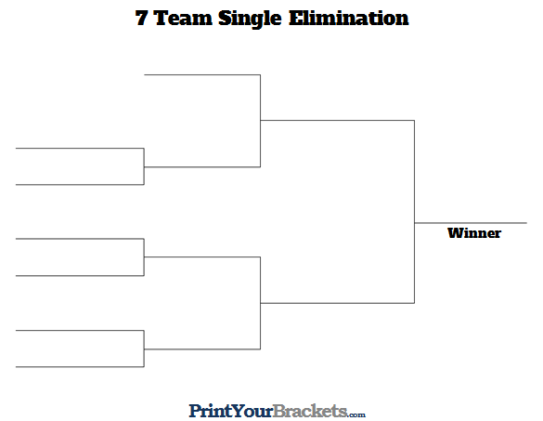

Soccer Terms

Attacker- the player with possession of the ball
Center Line-the halfway line drawn across the center of the field
Corner Kick- A direct free kick taken from the corner. It happen when the ball goes across the goal line and was last touched by a defender.
Cross-when a ball comes across the field from a sideline towards the goal.
Dribbling- using touches with your feet to control the ball.
Goal Kick- A goal kick is taken by the defending team when the ball goes over the goal line and was last touched by an offensive player.
Goal Line/End Line- The boundary line at each end of the field where the goals are.
Hand Ball- The INTENTIONAL use of the hands by a field player. The result is a direct free kick.
Marking- the defensive concept of guarding another player
Offside-when a receiver of a pass is positioned on his opponents half of the field with less than two defenders between him and the end at the moment the ball is passed.
Pitch- a soccer field.
Striker- a player whose primary duties is to work the attacking half of the field.
Tackling- Using your feet to steal the ball from an opponent.
Touchline- The lines at the side of the field.

